CRM62 & CRM84 Video Switch Upgrade

DVB100 Installation Guide

Installing the DVB100 expansion board into the CRM series video switch is approximately the same level of difficulty as installing an expansion board in a PC. You will need the following equipment for the installation. Video Storm LLC is not responsible for any damage resulting from improper end user installation of this product. If you do not have the proper equipment or do not feel confident with the procedure, please contact support@video-storm.com and arrange for a free factory installation.

Required equipment:
- ESD safe (static free) work area including personal ESD static dissipative device
- Philips screwdriver
- DVB100 expansion board
- Included 10 pin ribbon cable
- Included 6 small #6 Philips screws
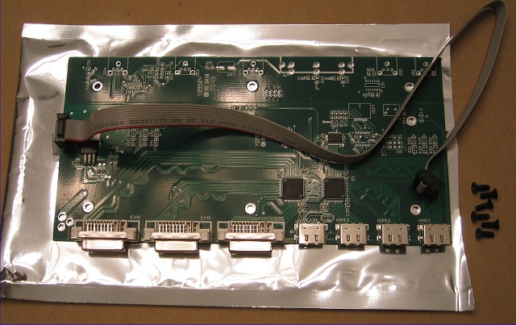
It is very important that you disconnect POWER and ALL external cables from the CRM switch before beginning. Do not open the case when the device is powered OR connected to any other cables.

NOTE: If any ribbon cables become loose during disassembly or reassembly, please make sure they are not reinserted with the wrong orientation, as this can damage the unit. If you are not sure which way to insert ribbon cables, please contact support.

Please read through all the steps below prior to starting. If you have any questions, please contact support@video-storm.com.

- Remove the front panel
  - Locate the six screws on the front panel (pictured). Remove these screws.
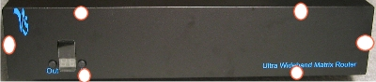
  - Lay the front panel down while leaving the ribbon cables attached as shown. Do not remove the ribbon cables.
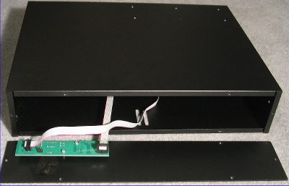
- Remove the cover screws from the back panel
  - Locate the three screws on the rear panel that secure the top cover (pictured). Remove these screws.
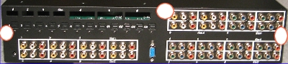
- Remove the cover screws from the right and left sides
  - Locate the two screws on each side (4 total). Remove these screws. If you have the rack ears attached you must remove these first.
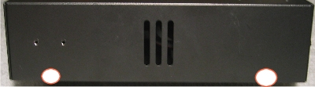
- Remove the top cover
  - While facing the rear panel, hold the top cover from both sides and slide back about 1 inch and pick up. The top cover should be removed in this fashion. This can be a bit tricky so you may need to try several times. The screw taps on the cover may catch on the optical or rca boards so be careful not to force these.
  - Place the top cover upside down near the left side as shown.
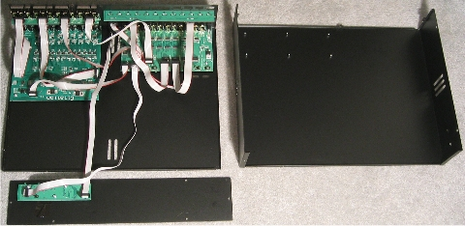
- Attach the DVB100 to top cover
  - Place the DVB100 on the six screw studs in the top cover. The holes on the board should align with the screw studs. Note there are three extra holes on the DVB100 which are not used. The connectors on the DVB100 should be right side up (refer to picture in “6” below).
  - Install the 6 screws to firmly attach the board to the cover
  - Verify that the ribbon cable to correctly attached to the DVB100. The red wire should align with the pin 1 designator (see picture).
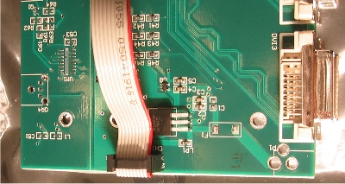
- Connect the ribbon cable
  - Select the pin set you will connect to. You may connect to one of the following pin sets (HD_DVI, HD_MB). The pin set name can be seen in small white lettering on the board. Select the one that is nearest to the left side and does not already have a cable connected to it (see picture). Depending on the product, one of these may already have a cable attached. Do not remove any attached cables. 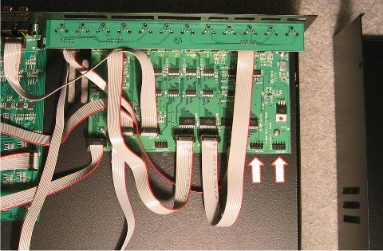
  - Attach the ribbon cable from the DVB100 to the pin set that you selected. Verify that the red wire aligns with the pin 1 designator (see picture). The ribbon cable should be long enough for you to make this connection when the top cover is adjacent to the left side of the CRM switch.
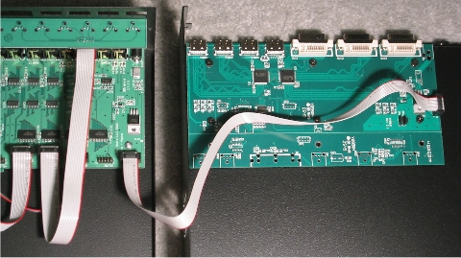
  - Double check that the red wire on the ribbon cable aligns with the pin 1 designators on both the DVB100 board and the CRM board. If this cable is reversed, it will damage the board once it is powered up.
- Re-attach the top cover
  - Flip the top cover back over and re-attach to the CRM switch. Make sure you do not dislodge the ribbon cable.
  - The top cover is installed by first aligning the right side when the cover is about 1 inch away from the back panel. Then align the left side and slide the cover all the way to meet the back panel. This can also be quite tricky and require several tries to get to perfect. Once again make sure the rear screw taps do not get caught on the CRM boards.
  - The cover is properly in place when the screw holes line up. If the screw holes do not align, you need to re-attach the cover again. Do not force screws into the holes.
- Insert the Rear panel screws (3)
- Insert the side panel screws (4 total)
- Reattach the front panel
  - Hold the front panel up to the front of the CRM switch.
  - When the screw holes are aligned, insert the top 2 screws firsts. After these insert the remaining 4 screws.
- Finally check to make sure all screws are attached
- Power up check
  - Plug in the DC power cable
  - Press the front left button
  - If the LED does not come on, the installation was done incorrectly. Immediately disconnect the DC power cable and contact support@video-storm.com.
  - If the LED is normal, continue to press the left button until you see “H” in the display. If this appears, the DVB100 has been detected and installed. Refer to the CRM manual for operating instructions. If you do not see an “H” when you cycle through all the values, the installation has been done incorrectly. Immediately disconnect the DC power cable and contact support@video-storm.com.

